Nexora record listings and saved views
Document 7 of the Nexora learning guides
Source snapshot 14 October 2026 at 06:41 UTC
Learn the shared search, filters, column chooser, sorting and saved-view code used across modules.

Recognise the screen and its scope
Open /relationships/contacts, /membership/members, /finance/orders, /insights. CRM routes use port 3017; member routes use 3018; public website routes can use 3019. Brackets name a route parameter, not text to paste into a browser. Choose a real record or site id from the application.
This guide covers Search and filter toolbar; Column chooser; Sortable headers; Client and server sorting; Personal saved views; Paging selection retry and all records.
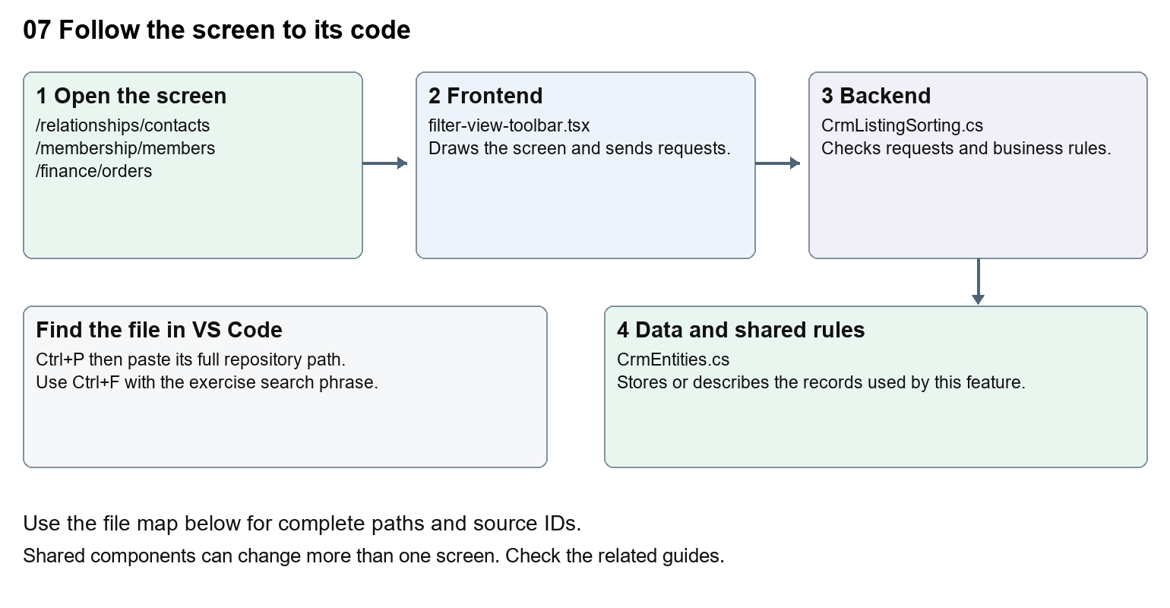
The diagram shows the file roles. The full paths below are what you paste into Ctrl+P.

Find the files in VS Code
Role | File and source ID | What it does
Screen | S0141 filter-view-toolbar.tsx | Main UI or route for this topic
Server | S0249 CrmListingSorting.cs | Endpoints or server rules
Data | S0255 CrmEntities.cs | Data shape or persistence structure

Screen S0141
apps/web/src/features/shared/filter-view-toolbar.tsx
Server S0249
backend/src/Modules/Nexora.Modules.Crm/CrmListingSorting.cs
Data S0255
backend/src/Modules/Nexora.Modules.Crm/Domain/CrmEntities.cs
The complete HTML manual opens these source IDs inside its Source library. The Word manual shows short labelled extracts so you can learn the flow before reading large files. Each individual Markdown guide includes its complete primary files after the walkthrough.

Follow the request and the records
1. A workspace passes rows, filters and callbacks to shared listing controls.
2. Search and filters update query state or local filtering, depending on the module.
3. A sortable header asks for an ascending or descending key.
4. CRM and Membership validate supported server sort keys; some smaller lists sort loaded rows in the browser.
5. The refreshed list renders with the chosen visible columns.

Read the code with an explanation
Shared components are used by several workspaces, so a wording change can affect multiple modules. useCrmListing loads server pages; useEntityListing supplies shared controls and client matching. A saved view is a stored query definition, not a copy of the records. Column visibility and saved filters are different pieces of state; inspect the relevant hook before changing persistence.
Source reference S0141 apps/web/src/features/shared/filter-view-toolbar.tsx
Selected opening lines with their original numbers. The complete file is in the HTML source library.
0001 "use client";
0003 import { useEffect, useId, useRef, useState, type ReactNode } from "react";
0004 import { ChevronDown, ListFilter } from "lucide-react";
0008 export function FilterViewToolbar({ search, actions, filters, onAllRecords, onMyRecords, disabled = false }: {
0009 search: ReactNode; actions?: ReactNode; filters: ReactNode;
0010 onAllRecords: () => void; onMyRecords?: () => void; disabled?: boolean;

The import lines lead to shared components and helpers. Start at the exported component or route function; follow the request helper to the server rather than assuming the whole feature lives in this file.
Source reference S0249 backend/src/Modules/Nexora.Modules.Crm/CrmListingSorting.cs
Extract from source line 14. A fragment from a long line is shown without the rest of that line.
0014 public static async Task ValidateAsync(CrmDbContext db, string kind, string sort, CancellationToken ct)

On the server, look for MapGet to load records, MapPost to create or perform an action, MapPut or MapPatch to change data, and RequireAuthorization for permissions. Some shared methods register endpoints indirectly. Find SaveChangesAsync to see the database write. A request method alone does not tell you every side effect.
Source reference S0255 backend/src/Modules/Nexora.Modules.Crm/Domain/CrmEntities.cs
Selected opening lines with their original numbers. The complete file is in the HTML source library.
0001 namespace Nexora.Modules.Crm.Domain;
0003 public abstract class TenantRow
0004 {
0005 public Guid Id { get; set; } = Guid.NewGuid();
0006 public Guid TenantId { get; set; }
0007 }

Follow model fields to their request names and database mapping. An id points to a particular record. A tenant id limits the organisation. A version or concurrency stamp protects newer edits. Some model files describe contracts rather than tables; check the owning DbContext before assuming storage.

Make or trace your first change
1. Press Ctrl+P and open apps/web/src/features/shared/column-chooser.tsx.
2. Press Ctrl+F and search for Columns. In this snapshot it appears at line 57.
3. Read-only exercise: locate the visible Columns label, then trace where ColumnChooser is imported. Write down two workspaces that would be affected by changing this shared component.
4. Record the file, request path and server handler you found. This exercise is read-only; no stored records need to change.
Extract from source line 57. A fragment from a long line is shown without the rest of that line.
0057 ={styles.heading}><h2 id={titleId}>Columns</h2><button type="button" className={styles.

These exercises have not been applied to the application. Their search phrases are verified against the captured source. Line numbers can move; the phrase and file path are your main navigation aids.

Check a change and diagnose problems
Confirm the original screen still loads, the changed words appear in the intended place, and another screen using the same component still behaves correctly. If an action fails, inspect the browser Network response, the relevant helper and server validation message. Use the common error table at the beginning of the manual. Reload on a version conflict instead of removing the version check.
A syntax error after a text edit usually means a quote, brace or closing tag changed. Compare your diff with the original. An unchanged browser result can mean the wrong port, a saved published configuration overriding a default, or a running API that has not reloaded.

Understand the current limits
Sorting behaviour differs between server-paged and locally loaded lists. Keep the API sort allowlists and UI keys aligned. A new column needs a data source and corresponding cell; renaming its label alone cannot create stored data.

Continue learning
Related guides 05 Nexora CRM contacts, 06 Nexora CRM accounts and associations, 09 Nexora member records and subscriptions, 19 Nexora insights and reporting.

